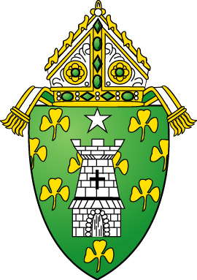
DIOCESE OF NORWICH
VIDEO CONFERENCING PERMISSION SLIP
PROVIDING CONSENT & RELEASE OF CLAIMS

Despite the COVID-19 pandemic, the Diocese of Norwich continues to serve the children and youth of (SAINT PIO PARISH). In some instances, Parish program(s) are providing virtual programming and content for participants, whereby staff will facilitate program activities through online platforms. Such program(s) will use software, tools, and computer applications provided by third-parties that participants, parents/legal guardians, volunteers, and/or staff will access via the internet and use for purposes of communication, programming, and potential content creation.

These platforms include virtual video conferencing. Completion of this Form indicates your consent and release for your child to participate in the program(s) and utilize the online applications for distance-based, virtual program purposes. Please be aware that each video conference application collects information about its users and has its own privacy terms and conditions to which users must adhere and which neither the parish nor diocese can control or assume responsibility. Please review these carefully before registering your child. Our commitment to keeping the children and youth we serve safe is always our number one priority. To that end, we will actively monitor participant activity. All online activities contemplated hereunder must also comply with the Diocese of Norwich- Office for Safe Environment Pastoral Code of Conduct as well as the Policy for Video Conferencing with Young People.
Permission to Participate:
I grant permission for my child-youth,__________________________________________, to participate Child’s name
in online Catechetical/Youth Ministry events during the 2020-21 church school year. All online classes, programs, events, etc. will be monitored by at least 2 safe environment certified adults at all times. I have read this Consent and Release Form and have had the opportunity to consider its terms and understand them. I verify that I have read and voluntarily agree to the terms and conditions of the Consent and Release Form – Policy for Video Conferencing with Young People. On behalf of my child and myself, I further hereby hold harmless, release and forever discharge the Diocese of Norwich and the Parish, along with their respective employees, agents, licensees, and legal representatives from, and shall indemnify them against, all claims, demands, and causes of action which I, my heirs, representatives, executors, administrators or any other person(s) acting on my behalf or on behalf of my estate have or may have by reason of my Child’s participation in the program(s) and through my authorization, consent and release herein. I have read this Consent and Release Form, I fully understand it, and I voluntarily agree to be bound by its terms. I represent and certify that I am the parent or legal guardian of the child named above.
Parent/Guardian Name: _________________________________________ Signature:_____________________________________________________
Email: _________________________________ ___ Cell Phone: _________________________________
Address: ___________________________________ City: ______________________ State: Connecticut

